Harris County Domestic Violence
Coordinating Council

Adult Violent Death Review Team

2015
Annual Report

“she

really thought he loved her . . . she really thought that he loved her”
–
Victim’s Mother
, Family Interviewing Project

We dedicate this report to all the people affected by
Intimate Partner Violence—survivors, family members, friends, co-workers, service providers, law enforcement and especially those who lost their lives as a result.
May we all strive to end violence.

This report would not be possible without the hard work and dedication of the Adult Violent
Death Review Team members (AVDRT). The AVDRT would like to thank Captain Dwayne Ready and the Houston Police Department’s Homicide Division. Without their support and
cooperation our reviews would be not be as comprehensive. The Team would also like to thank the families that shared the stories of their loved ones with us. Your kindness, strength and courage are unmatched.

January 2016

The year 2015 was an impactful year for the Adult Violent Death Review Team (AVDRT). Were convened after a two year break which included several community assessments, the beginning of family interviewing, and many new team members. If this is your first introduction to the AVDRT, let me provide a brief history. Each month a group of passionate advocates and investigators meet to review domestic violence homicides/suicides that have taken place in the Houston/Harris County community. The purpose of these meetings are to conduct a formal, confidential, and system-wide review; with the end-goal of creating and sustaining change in the “systems” within the Harris County community. Community collaborations of this degree are difficult to duplicate; this team has been meeting routinely since 1996 and its members are committed to seeing the end to domestic violence homicides and suicides.

Homicides and suicides are not easy to read about; this is an important report and I encourage you to review this with care knowing that we as a community still grapple with the loss of life, the impact of violence on children, and the impact on those advocates who assist surviving family members during the most difficult time of their lives.

This report marks the end of my tenure as the Chair of the AVDRT. My ten years of chairing this team has been an honor and an amazing learning experience. I have been surrounded by professionals from many different walks of life, each bringing their own passion and expertise to the table. I have been forever changed by this work and these people.

Donna Amtsberg, LCSW
AVDRT Chair
Clinical Assistant Professor
Director, Child Trauma Program
Graduate College of Social Work
University of Houston dkamtsberg@uh.edu 713-743-1491

Adult Violent Death Review Team Agency Members

Aid to Victims of Domestic Abuse
The Bridge Over Troubled Waters, Inc.
Cenikor’s Odyssey House District Attorney’s Office, Victim Witness Division Domestic Violence Coordinating Council
Harris County Sheriff’s Department Homicide + Family Violence Unit

Houston Area Women’s Center Houston Community College System Houston Police Department Homicide + Family Violence Unit Northwest Assistance Ministries, Family Violence Center Texas Department of Family and Protective Services (CPS & APS) Shalom Bayit University of Houston, Graduate College of Social Work

Harris County Adult Violent Death Review Team Members

Donna Amtsberg, Chair
University of Houston Graduate School of Social Work

Lori Albee  Adult Protective Services | Sherri Kendall  Aid to Victims of Domestic Abuse
Antrece Bagett  Houston Community College System | Lisa Levine  Houston Area Women’s Center
Sherryl Becker  Texas Department of Family and Protective Services | Barbara McInnis Houston Police Department
Barbie Brashear  Harris County Domestic Violence Coordinating Council | Deborah Moseley  The Bridge Over Troubled Waters
Rhonda Cartwright  Harris County Community Supervision and Corrections Department | Toby Myers  Shalom Bayit
Captain Sean Conrad  Harris County Sheriff’s Office | Michelle Permenter  Harris County District Attorney’s Office
Megan Hoag  Adult Violent Death Review Team Research Assistant | Rachel Portnoy  Adult Protective Services
Nicole Huff  Cenikor’s Odyssey House | Amy Smith  Harris County Domestic Violence Coordinating Council
Sgt. Greg Jackson Houston Police Department | Lt. Kira Webster Houston Police Department

Contents
Adult Violent Death Review Team Agency Members vi
Harris County Adult Violent Death Review Team Members vii

Contents ................................................................................................................. Error! Bookmark not defined.
Introduction .......................................................................................................................................................... 1
Harris County Domestic Violence Coordinating Council Background .............................................................. 2
Intimate Partner Violence Fatality Review ....................................................................................................... 2
Cases of Intimate Partner Homicide in Harris County, TX .................................................................................... 4
Overview ........................................................................................................................................................... 4
Case Review Selection Process ......................................................................................................................... 5
Family Interviews .............................................................................................................................................. 5
Limitations ........................................................................................................................................................ 6
Summary Data of Cases Reviewed........................................................................................................................ 7
Fatality Details .................................................................................................................................................. 7
Victim & Perpetrator Demographics ................................................................................................................ 9
Victims ........................................................................................................................................................ 10
Relationship .................................................................................................................................................... 11
Living Arrangement ..................................................................................................................................... 11
Age Difference ............................................................................................................................................ 12
Children .......................................................................................................................................................... 13
Children Who Lost A Parent ........................................................................................................................ 14
Perpetrator History ......................................................................................................................................... 15
Criminal History .......................................................................................................................................... 15
Risk Factors ................................................................................................................................................. 16
Sentencing ...................................................................................................................................................... 17
Lessons Learned About the Review Process and Our Community ..................................................................... 18
Challenges ................................................................................................................................................... 20
Changes for Next Year ................................................................................................................................ 20
2016 AVDRT Recommendations ......................................................................................................................... 21

Harris
County Domestic Violence Coordinating Council

Harris County
Domestic
Violence
Coordinating
Council

Adult Violent Death Review
Team

Introduction

E
ach year in the St
ate of Texas, Harris County (
the State’s largest
county) has the highest number of women who are killed by their
intimate partners.
Harris County is the third largest county in the
United States with a population of more than 4.1 million people.
In
2014
, 132 women in Texas were killed by their intimate partners.
Twenty
-
eight of those deaths occurred in Harris County, (Texas
Council on

Family Violence, 2015).
Every year, the
Harris County
(
Council
Coordinating
Domestic
Violence
HCDVCC)
gathers
information related to service delivery from our local partners. We
know that there are over 35,000 calls to law enforcement on an
annual basis

in Harris County, and more than 82,000 calls to
domestic violence hotlines within the county (HCDCVCC annual
collection of data from domestic violence systems, 2012). It is
estimated that 1 in 3 women are victims of domestic violence in their
lifetime (C
atalano, S, 2007).

“I never thought he
would hurt her, up
until the very end
when they separated
the last time. That’s
when I started
believing he would
actually hurt her,
because . . . he had
tried everything,
there was nothing left
for him to try.”

–
Victim’s Moth
er
,
Family Interviewing
Project

Harris County Domestic Violence Coordinating Council

According to Futures W
ithout Violence:

•

On average, more than three women are murdered by their husbands or boyfriends
in this country every day.

•

Of females killed with a firearm, almost two
-
thirds were killed by their intimate
partner.

•

Women are much more likely than men to be killed by an intimate partner. In 2005,
intimate partner homicides accounted for 33 percent of the murders of women but
less than four percent of the murders of men.

Harris County Domestic Violence Coord
inating Council Background

Harris County has a 20
-
year history of working toward creating community collaborations that
impact systemic change for survivors of domestic violence. The Harris County Domestic
Violence Coordinating Council (HCDVCC) was form
ed in 1996

in response to
identifying
collaboration as an essential building block to establish a coordinated
and systemic response. The
efforts to coordinate have evolved out of frustrations with the fragmentation of the policies and
activities of the
various agencies serving victims of domestic violence. These frustrations have
been expressed by victims, the community
,

and the service providers themselves.

HCDVCC serves as the coordinated community response for domestic violence and plays a
central
role in increasing collaborations among service providers. Because there are more
than 100 different organizations from various systems responding to victims of domestic
violence, collaboration building was identified as an essential building block to add
ressing the
barriers to increasing safety for victims, and decreasing violent deaths. HCDVCC is
distinguished by its strong, volunteer board of local leaders, which include representatives
from the Harris County District Attorney's Office, Houston Police D
epartment, Harris County
Sherriff’s Office, Pasadena Police Department, and Executive Directors of
various

victim
service agencies. HCDVCC is positioned to be an agency whose sole interest is working to
create strong collaborative partnerships in the commu
nity that increase communication
among services providers to effect positive change.

Intimate Partner Violence Fatality Review

As domestic violence work progressed across the United States, it became clear in many
communities that there was a need to for
m fatality review teams; the purpose of which is to

Harris
County Domestic Violence Coordinating Council

review domestic violence
-
related homicide cases and ident
ify needs within each community
with the ultimate goal of decreasing the incidence of preventable adult deaths.

In 2001 the Texas Legislature pass
ed Senate Bill 515 amending Chapter 672 of the Texas
Health and Safety Code to allow for the formation of adult fatality review teams in Texas
counties. In August of 2003 the AVDRT was designated as the official Harris County adult
fatality review team by
Harris County Commissioners Court.

Each month the AVDRT conducts system
-
wide reviews of selected cases of adult unexpected

deaths that have been caused by intimate partner violence occurring in Houston and Harris
County.

•

To conduct formal,
confidential and systematic evaluation and analyses of
adjudicated cases of family violence occurring in Houston and Harris County, focusing
on the flow of each case through the various agencies in the system to identify areas
for improvement or strengthen
ing of agency contacts and interagency response.

•

To evaluate policies, protocols, and practices to identify gaps in service within
agencies and the community.

•

To build a database for analysis of aggregate population of deceased persons and
perpetrators.

•

To disseminate information on prevention strategies through a bi
-
annual quantitative
and qualitative report to the AVDRT, HCDVCC, and as required to the Texas
Department of Protective and Regulatory Services and to the community at large.

“
”s
he was high s
pirited, very high spirited, and very ambitious . . . and
she had a heart, a heart of gold . . . all of a sudden, that spirit . . .
came all the way down . . . if she walked out the door, she had to call
and let him know that she walked out the door and I
got to thinking,
there is something not right with this . . . that’s not a healthy
relationship if you have to call every time you make a move”

–
Victim’s Mother, Family Interviewing Project

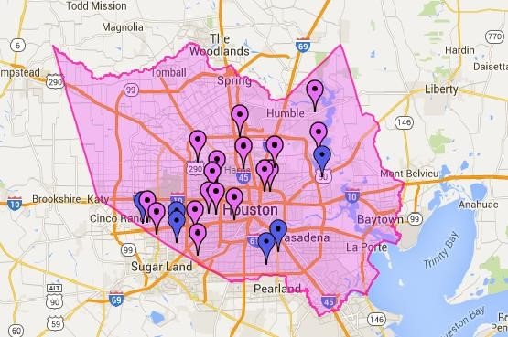

Harris County Domestic Violence Coordinating Council

Cases
of Intimate Partner Homicide in Harris County, TX

Overvi
ew

The case review data described in the 2015 report includes information from 17 cases of
intimate partner homicide in Harris County, TX from 2010
-
2012
. The data is based on the
number of cases reviewed by the team this year and does not reflect the tota
l number of
intimate partner homicides for the time period.

•

15
Cases Reviewed from
2012

•

1
Case Reviewed from 2011
[
^
Evidence was presented to a Grand Jury who
determined that the person acted in self
-
defense so the case was no
-
billed.

Decedent
was the
main aggress
or with a long history of DV
.]

•

1
Case Reviewed from 2010
[
*Charges were dismissed because the

body has never
been found

but the defendant was convicted on a Federal gun charge.
]

Harris County, TX:

The purple markers represent the zip codes of the 17 cases we
reviewed and the blue markers represent the 6 cases provide to us that we did not
have time to review.

Harris
County Domestic Violence Coordinating Council

Case Review Selection Process

Intimate partner homicides are identified by the relation
ship between the victim and the
perpetrator as being current or former spouses or current or

former

dating relationships. T
his
definition includes all intimate partner homicides regardless o
f the gender of the perpetrator,
including

same sex couples.

The

case list for the review process is generated by the Harris County District Attorney’s
Office. The list only includes cases where charges were filed

by the police agency and
accepted for prosecution by the Harris County District Attorney’s Office
. The l
ist may or may
not include murder/suicide cases. The total number of cases on the list to be reviewed by
the team during this time period was 23. Due to time constraints only 17 went th
rough the
entire review process.

Family Interviews

In hopes of
learning more about the lives of these victims and additional opportunities for
interventions and system changes, we spent the better part of the year developing the
process and policies for the inclusion of family interviews in our yearly review
.

Of the

17
cases reviewed we only had contact information on 9 of the families, with most
information being outdated and no longer available as mos
t of the cases were 3+ years old
.
Of the 3 families that were contacted
,

only 2 agreed to meet with select team mem
bers. The
third family did not believe their loved one’s case was an intimate partner homicide, although
case documents indicated that it was a same
-
sex relationship
.

The family interviews provided insightful information into the
challenges the victim
and the
family experienced leading up to the murder and the strength that has carried them forward
since then.
Not only did they provide
us helpful details about the

history of the violence in the
relationship
,
but of the relationship it
self,
the family’s
perception of what was happening to
their loved ones
, and their reflections on what needs to change in order to prevent this from
happening to others. We are humbled by the graciousness and openness of the families that
a
llowed us to interview them and m
ost of all we are
awed and
inspired by their strength and
resilience
.

Harris County Domestic Violence Coordinating Council

Limitations

Our findings align with the current nationwide data
available on intimate partner homicides, however,
we
recognize that the data
we
captured is only a snapshot
of
these

homicides.

O
ur review process does have several
limitations
,

including:

Access to
Rel
evant Case
Information:

Not everyone that
we would like to be at the table is currently
there. Our
access to a case is limited to the
information
current

team members
are able to gather and share
. While
everyone at the table is open and honest with their

information
,

many unanswered question
s remain.

Accessing
Data
:
The databases of team member agencies
were not designed to pull data for the purposes of the
review
.

Thus, data gathering is often

a cumbersome
process for already time
-
constrained agencies

and team
members
. There is additional data we would like to
access for the review, but we must be cognizant of the
time and effort each additional request places on team
members and their agencies. Additionally, the State of
Texas does not have a system in

place to collect
statewide and county level

data on

intimate partner
homicides.
A statewide tracking system would allow for
easier access to data and information.

Access to
More
Current Cases:

The majority of the 17
cases reviewed in 2015 were from 201
2
, with one being
from 2010 and one from 2011.
The District Attorney
provides us access to
cases that have gone through the
first stage of disposition, meaning the
defendants

have
pl
ed guilty or were found guilty. These reviews have
allowed us to identify
gaps within systems and identify
areas for improvement within our community. However,
because these cases happened 3+ years ago, it can limit
our ability to provide up to date recommendations as
some issues we identify in the review
have already been
resol
ved by the time we review
ed

the case.

“I was tempted to call
him over, hit her
myself and set him
up . . . to just end the
madness . . . for
somebody like me to
even start thinking
like that, it has got
ten
really bad and you
feel like there is no
other way out . . .
we’re just not like
that, but us not doing
something cost her
life.”

–
Victim’s Mother
,
Family Interviewing
Project

Harris
County Domestic Violence Coordinating Council

Summary Data of Cases Reviewed

Fatality Details

The majority of the homicides

from our case reviews

fall within three

categories, with gunshot
wounds resulting in two
-
fifths of the homicides

17)
of
(7
, followed
by more than one
-
fifth
from stab wounds

(4
of
17)
, and nearly one
-
fifth

from strangulation

17)
(3
of
.

In two of the seventeen cases reviewed, the perpetrator committed suicide after killing the
victim. In both cases the perpetrator was a male and the met
hod of suicide was a gunshot to
the head.

In nearly one
-
fifth

of cases reviewed

17)
(3
of
, there were c
ollateral victims resulting in two

deaths (victim’s c
ousin, victim’s boyfriend) and one

non
-
life threatening injury (victim’s
friend’s boyfriend). All w
ere the result of gunshot wounds.

In the cases reviewed, more than two
-
fifths of perpetrators

(7
of 16)
had

drugs and/or alcohol
in their system at the time of the homicide
(
^2011 self
-
defense case not included
).

“
When she died, it was at that point when
the police asked
me was she abused. ‘What do you mean?’ She had marks
and things on her back . . . we never knew . . . the way that
he did her, it was violent, it was very, very violent”

–
Victim’s
Mother
, Family Interviewing Project

41
%
%
23
18
%
%
6
6
%
6
%
Cause of Death
Gunshot Wounds
Stab Wounds^
Strangulation
Blunt Force Injury
Strangulation, suffocation, &
blunt force injury
Unknown*
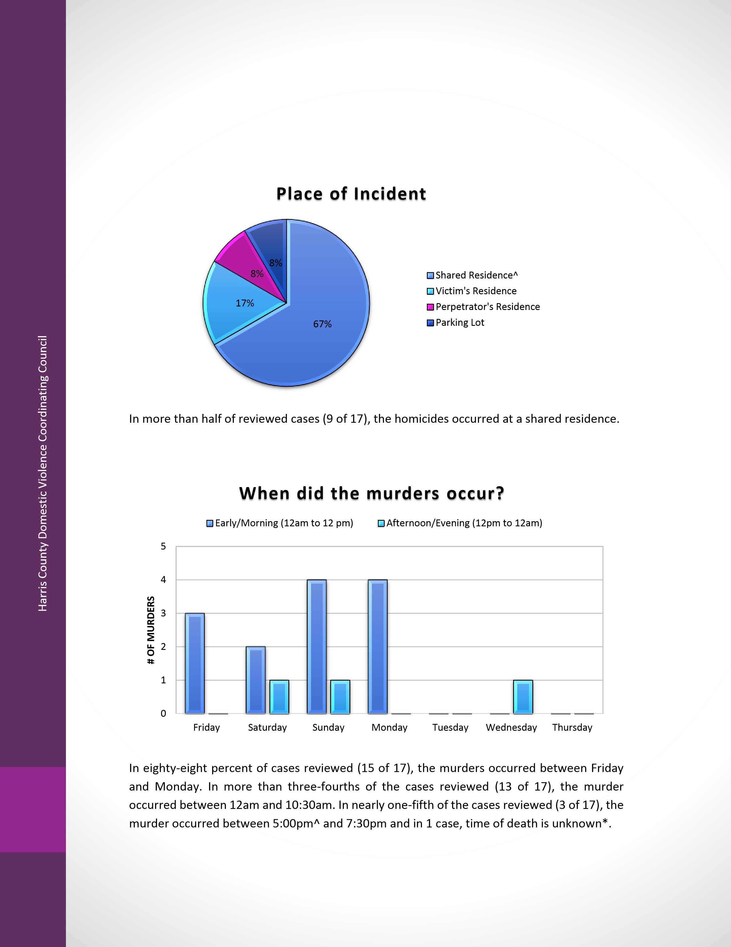
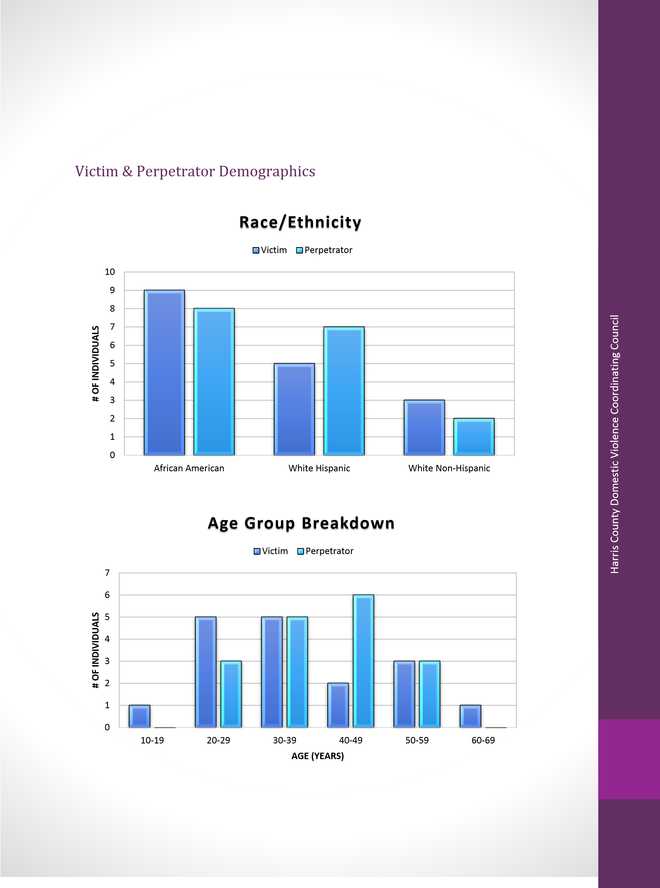

Harris County Domestic Violence Coordinating Council

Victims

Of the cases reviewed, more tha
n three
-
fourths of the victims were female

(13
of
17)
. Of the male victims, one was the main aggressor in the self
-
defense case. About half of
the victims were African
-
American

(9
of
17)
, while twenty
-
nine percent were Hispanic

(5
of
17)

and eighteen percent were White, Non
-
Hispanic

(3
of
17)
. More than half of victims were
between the ages of 20 and 39 at the time of the incident

17)
of
(10
. The average age for a
female victim was 32 years and the average age for a male victim was 56 ye
ars.

Perpetrators

Of the cases reviewed, more than four
-
fifths of the perpetrators were male

(14

of 17)
. Of the female per
petrators, one was included from

the self
-
defense case. Nearly half
of the perpetrators were African
-
American

(8
or
17)
, while abou
t two
-
fifths were Hispanic

(7

of 17)

and about one
-
tenth were White, Non
-
Hispanic

17)
of
(2
. About two
-
thirds of
perpetrators were between the ages of 30 and 49 at the time of the incident

(
17)
11
of
. The
average age for a male perpetrator is 39 years and

the average age for a female perpetrator
was 51 years.

%
53
%
29
18
%
Race/Ethnicity: Victims
African American
White Hispanic
White Non-Hispanic
47
%
%
41
%
12
Race/Ethnicity: Perpetrators
African American
White Hispanic
White Non-Hispanic

Harris
County Domestic Violence Coordinating Council

Relationship

Relationship Status

Of the cases reviewed, about three
-
fifths of relationships were dating

(10
of
17)
, while about two
-
fifths were married

of
(7
17)
, including common law and those
who w
ere separated with no divorce pending. One of the 17 cases was a same sex
relationship.

Living Arrangement

In more than three
-
fourths of the cases

17)
of
(14
, the victims and
perpetrators were living together at the time of the incident.

“My daughter’s name wasn’t on the lease. People say they
didn’t even know she was there. That’s how isolated it
was.”
–
Victim’s Mother, Family Interviewing Project

%
41
%
59
Relationship at Time of Death
Married [Including, common law
marriage and separated with no
divorce pending]
Dating
%
76
%
24
Living Arrangements at Time of Death
Living Together
Not Living Together

Harris County Domestic Violence Coordinating Council

Age Difference

Nearly half of all victims were younger than the perpetrator

17)
(8
of
.
Fe
males were on average 12 years younger than the perpetrator while there were no male
victims younger than the perpetrator.

More than one
-
third
(6
of 17)
of the victims were older
than the perpetrator (including all male victims) and on average female victi
ms were 4 years
older and male victims were 8 years older than the perpetrators. Additionally, eighteen
percent of victims were the same age as the perpetrator

17)
of
(3
.

“he was such a normal good guy . . . you didn’t see this, at
family functions, birt
hday dinners, whatever it was, you
couldn’t have asked for a better guy . . . we didn’t
know,
we didn’t
know”

–
Victim’s Aunt, Family Interviewing Project

0
1
2
3
4
5
6
7
to 29 Years Younger
20
to 19 Years Younger
10
to 9 Years Younger
1
No Age Difference
Years Older
1-9
# OF VICTIMS
Victims Age Difference from Perpetrator

Harris
County Domestic Violence Coordinating Council

“She loved him, yes she did, but I really think [she]
probably would have ended that relationship
long
before she did if it had not been for her kids”

–
Victim’s Mother, Family Interviewing Project

Children

Of the cases reviewe
d, 9 of them included children, equating to
more than half of the victims
having children. In five of the nine cases, all children were in common between the victim and
the perpetrator. In two of the nine cases, the victim had a child in common with the
perpetrator and a child that was not the perpe
trators biological child. In one of the nine cases,
there were no children in common, but the victim had an adult child/children that was not
the perpetrators biological child. In one of the nine cases, the victim had step
-
children who
were the biological
children of the perpetrator.

Yes
%
53
No
%
47
Did the victim have children?
Yes
No

Harris County Domestic Violence Coordinating Council

Children Who Lost A Parent

Of the nine cases, 23 children lost one or both parents [

*2010
case not included
—
number of adult children of victim is unknown
. Nearly three
]
-
fourths of
the children were minors
of 23)
(17
when
they lost their parents and one
-
fourth were adults

23)
(6
of
. Additionally, thirteen percent of children lost both parents

(3
of
23)
, as the
perpetrator committed suicide after the murder.

Children Present

During Incident

In four of the nine cases

(44%)
, the murder occurred
while children were present in the home, with 8 children being present at the time of the
homicide

(35%)
. Of the children present, half of them witnessed the event or discovered the
body

8)
(4
of
.

*Based on 9 cases and a total of 23 c
hildren
.

“We [children] didn’t talk, we were scared . . . what he would do to
us . . . he would whoop us, but it wasn’t like the normal whopping, it
was like for real”
–
Victim’s Daughter, Family Interviewing Project

17
4
Children Lost a Parent
23
Number of minor children who lost
a parent
Number of adult children who lost a
parent
15
%
65
8
%
35
Children Present During Incident*
Children Not Present During
Incident
Children Present During the
Incident
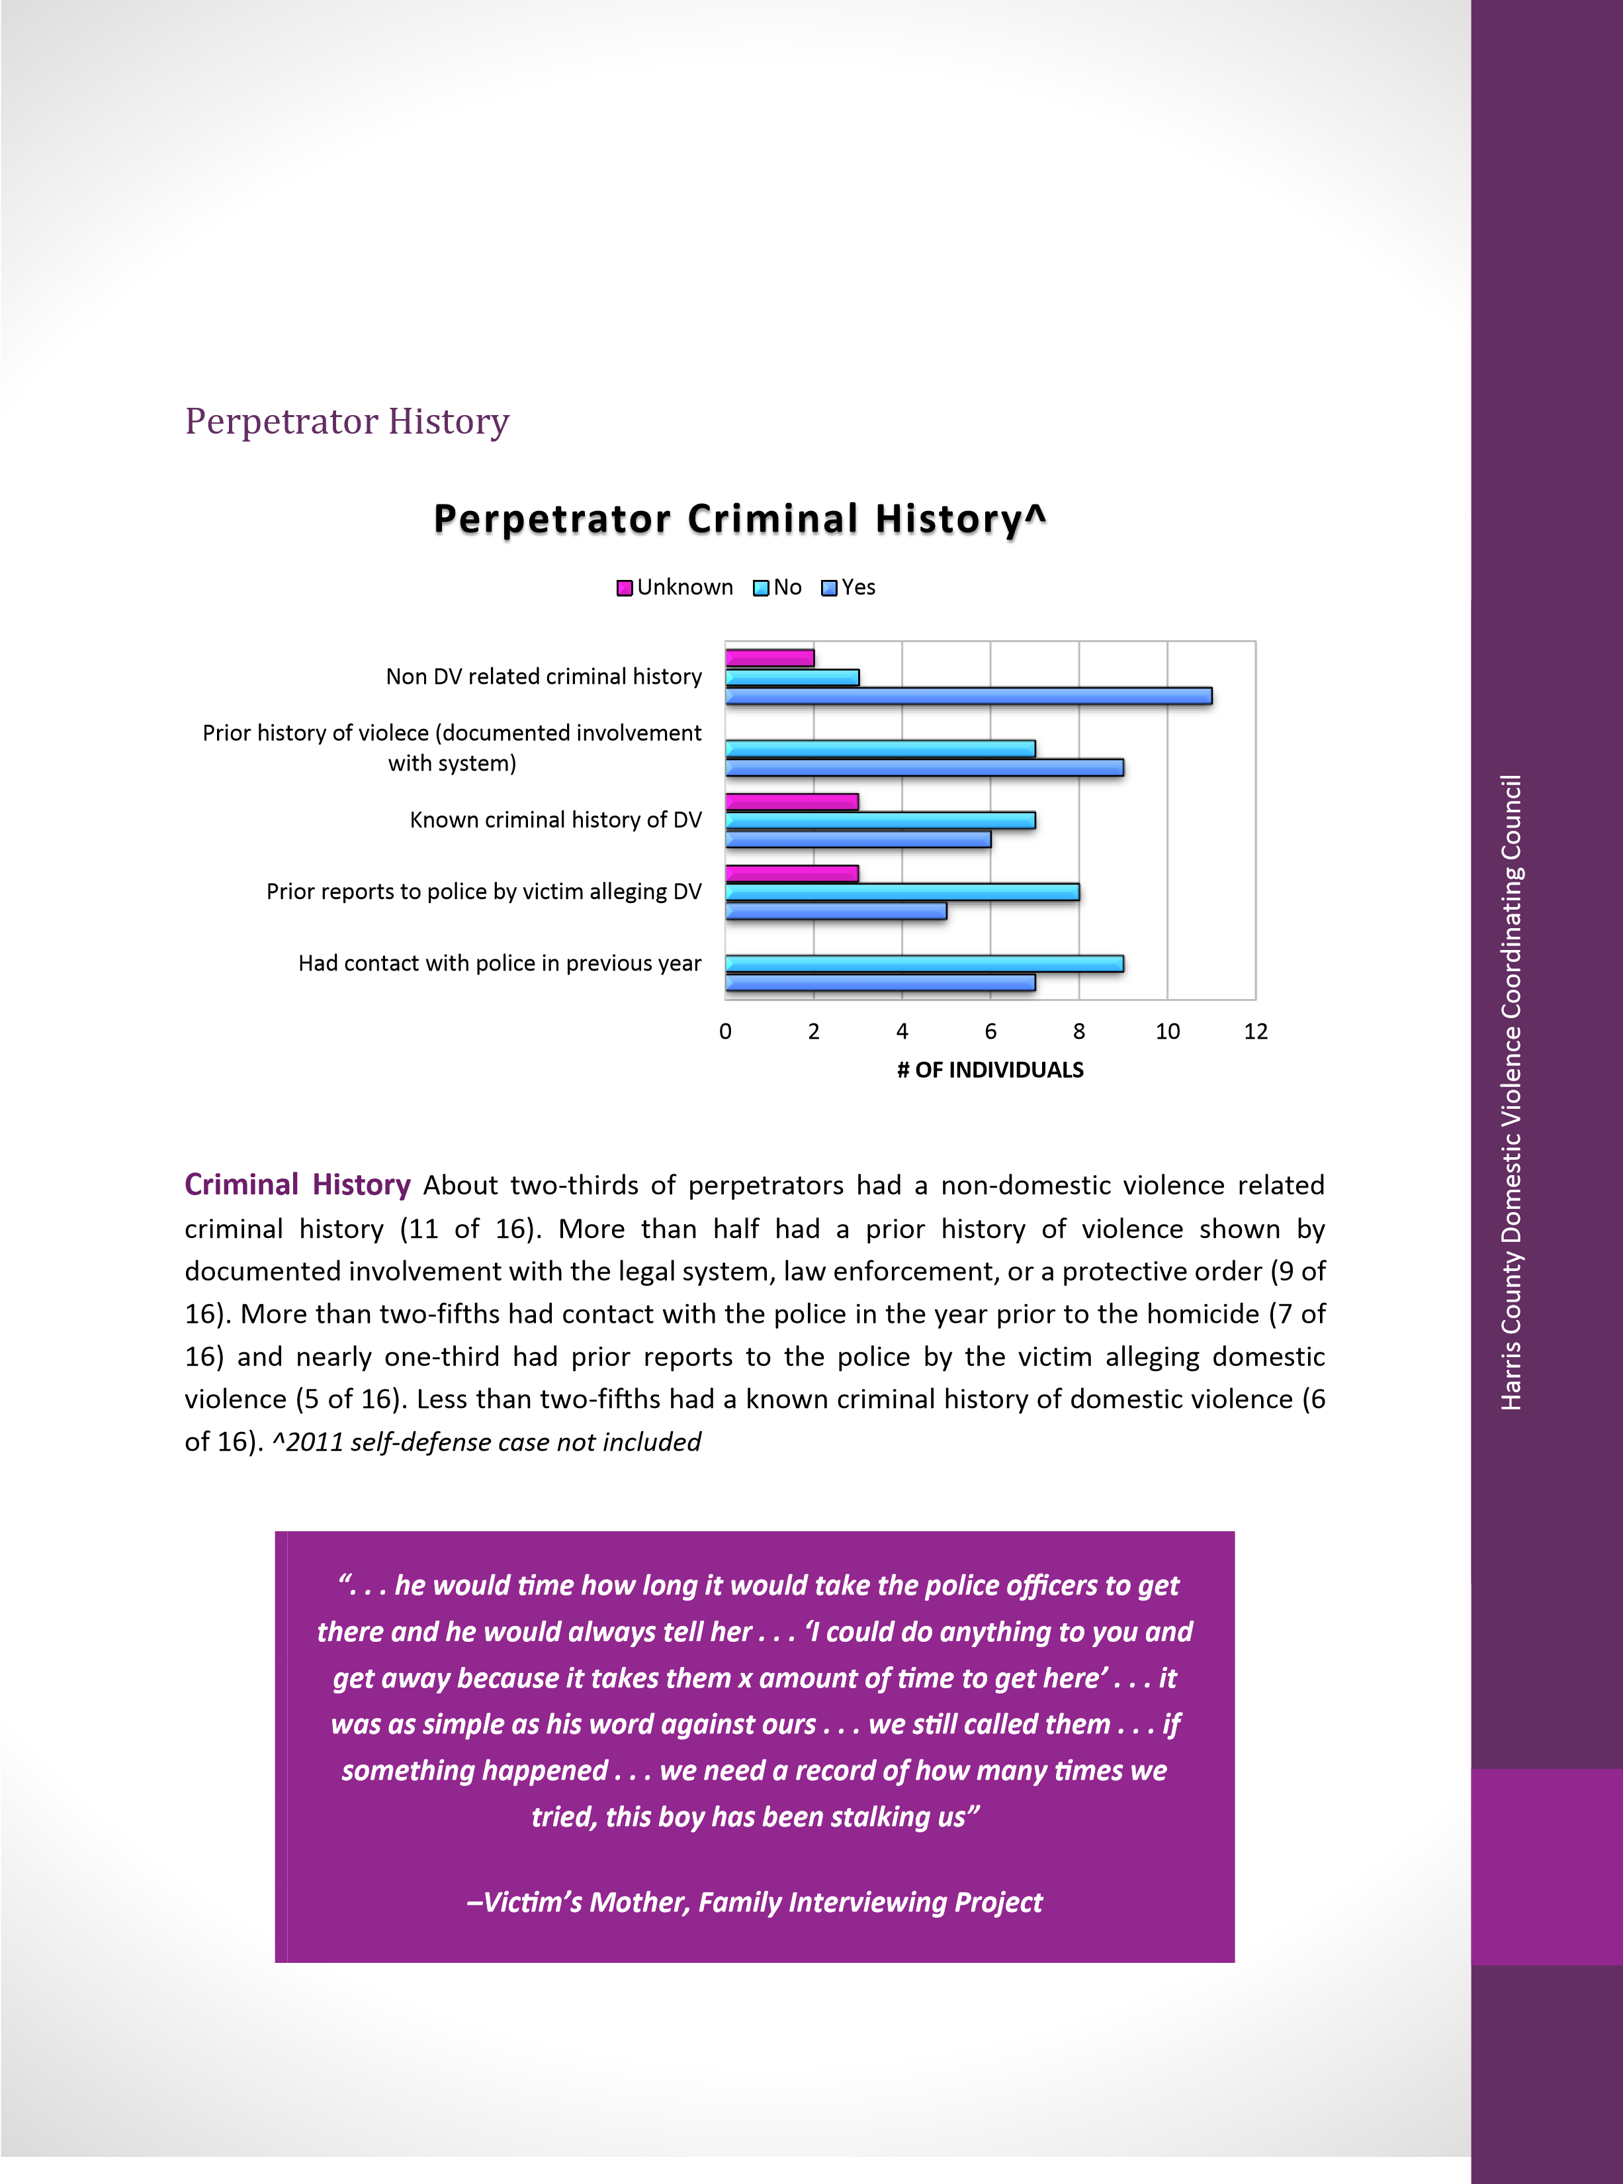

Harris County Domestic Violence Coordinating Council

Ri
sk Factors

In eighty
-
eight percent of cases, the perpetrators had a history of violence

(14
of 16), while the other two are unknown
. In more than two
-
fifths of cases, the victim had
previously attempted to leave the abuser

(7
of 16), while the other nine a
re unknown
.

In one
-
fifth of the cases the perpetrator had pre
viously threatened to kill the victim

of 16)
(3
and in
one
-
fifth of cases, the perpetrator had access to firearms

of 16), while the remainder of
(3
cases are unknown
. In
all of the unknown
cases, we were unable to determine

if there was a
history of violence, attempts to leave, threats to kill, or access to firearms.
^2011 self
-
defense
case not included.

“I knew he had access to some [guns] because some of
our family that we used to hang around and some of
his friends. We probably did have some in the house,
we didn’t know.”

–
Victim’s Daughter, Family Interviewing Projec
t

0
2
4
6
8
10
12
14
16
Victim: Previously attempted to leave
Perpetrator: Access to firearms
Perpetrator: Threatened to kill victim
Perpetrator: History of violence
Risk Factors^
Yes
Unknown
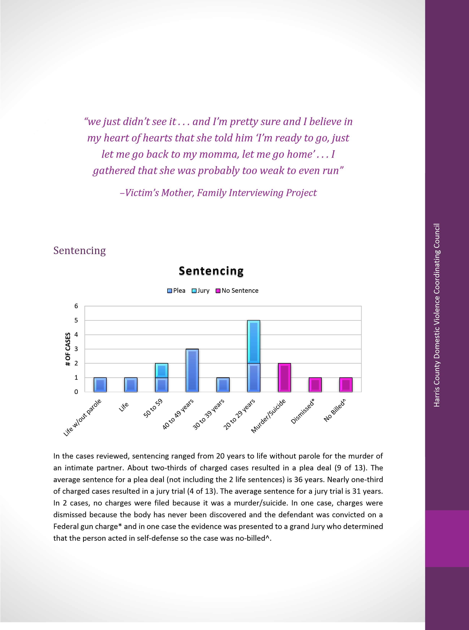

Harris County Domestic Violence Coordinating Council

Lessons Learned About the R
eview Process and Our
Community

•

Family interviewing is able to provide invaluable information for the team related to
the history and context of abuse experienced by the victims. Having the ability to
share the family story strengthens the team’s connect
ions with stakeholders and each
other, as well as leads to identification of systemic problems without judgement or
defensiveness. It allows us as a team to think beyond our own discipline.

•

Having a family interviewing protocol in place before conducting
the interview
provides structure and support for the process and keeps the interview on purpose.

•

Providing the team with team evaluations at the end of each meeting is helping to
keep the team focused on the process and purpose of the review, as well as al
lowing
the team to define what is working well:

o

Communication

o

Participation from law enforcement

o

Feedback from different systems

o

Opportunity to discuss case with law enforcement and DA’s Office

o

Having input from CPS about past of victims as well as offende
rs

o

Opportunity to explore context of the violence and other perspectives related
to the violence

•

Partnership with Law Enforcement and having investment from Houston Police
Department and the Harris County Sheriff’s Office is a true strength. Law
Enforcement leads the case review process by providing a
PowerPoint

presentation
that includes the 911 call, excerpts from the offender interview, a time line of the
incident, and any known history of the relationship.

•

Law Enforcement has shared that being able to “process” with the team allows them
as investigators to th
ink differently about the collection of information for future
cases. One investigator said during a review, “I wish I would have thought about
finding that out during the investigation.”

•

We are learning there is a need for follow
-
up, trauma informed se
rvices for families
who lose their loved ones due to domestic violence homicide. We are also
considering what

opportunities there may be

to provide connections among families
who have experience the loss of a loved one due to domestic violence homicide.

•

T
he presence of Adult and Child Protective Services offers insight from both a victim
and an offender perspective.

Harris
County Domestic Violence Coordinating Council

•

The diversity, experience, and wisdom of the individuals on the team bring collective
knowledge, wisdom, and insight to the case review.

•

It ha
s been enlightening to learn of the limitations due to protocols practiced by law
enforcement, and this also brings knowledge of how that system functions and the
role of law enforcement in homicide investigations that was not present to all
members and sy
stems represented on the team.

•

There is great value in having Battering Intervention and Prevention Programs
present as a team member.

•

HPD has already implemented a change to the letters sent to victims from the family
violence unit to include the Nation
al Domestic Violence Hotline as an additional
resource.

•

HPD changed their internal computer system for the ability to assign investigators to
assault cases in a more timely way.

“. . . if you feel it . . . you know there’s things out of the
ordinary, I
would tell the parent or whoever, if there’s
something out of the ordinary, if they stop calling . . . find
out what’s going on . . . anybody, if you see something . . .
if it’s out of the ordinary, say something . . nobody knew
nothing, nobody called.”

–
Victim’s Mother, Family Interviewing Project

Harris County Domestic Violence Coordinating Council

Challenges

•

The team is questioning the diversity of the team as members and as

systems. Who
are we missing?
Who is not represented?
As a team, we are not racially and ethnically
representative of the comm
unity we serve. There

is also a gap in representation from
the faith community.

•

There are continued limitations related to missing pieces from systems for the case
review.

•

The team still seems to work in isolation and seclusion and does not have a strong
sense of community recognition of the work that we are doing. There seems to be a
lack of visibility and awareness of the team and its role and function within a
coordinated community response to prevention of domestic violence.

•

There is a gap in state wi
de collection of data and there is no state wide sharing or
coordination of information.

Changes for Next Year

•

Work

to increase diversity within the team

•

Work to increase visibility and recognition of the work of the team

•

Solidify the family interviewing p
rocess and work to increase identification of families
for interviewing

•

Increase focus on the process and what we are looking for as a team

•

Create a process for retaining past protective order information (past the expiration
of the protective order) in th
e NCIC and TCIC systems for law enforcement access at
all times.

“When the woman say ‘I fear for my life’, believe it. Stop
that ‘oh he just mad’ . . . if I’m calling you, if I’m taking the
time to dial 911, please take it seriously . . . listen to these

women, help these women . . . life matters”

–
Victim’s Aunt, Family Interviewing Project

Harris
County Domestic Violence Coordinating Council

2016
AVDRT Recommendations

•

Strengthen the lines of communication among agencies and organizations

•

Identify additional opportunities and continue current efforts to
increase

public
awareness of available resources for all survivors and perpetrators of domestic
violence.

•

Increase and strengthen our educational efforts to prevent deaths due to domestic
violence

•

I
ncrease awareness of the societal imperative to recogniz
e the magnitude of the
problem and the difficulties associated with identifying, investigating

and prosecuting
domestic violence deaths

•

Educate law makers, government and public officials and members of the criminal
justice system about the increasing magn
itude of mistreatment in our community,
and the need for more rigorous action and increased funding to combat the problem.

•

Develop

a process for retaining information on previous protective orders after their
expiration date in law enforcement databases
. T
he information found in previous
protective orders may provide helpful insight into the history of the relationship and
identification of potential risk factors, which may assist
law enforcement in their
investigations.

•

Advocate for the creation
of a stat
ewide repository for domestic violence fatality
review information

through state legislation.

•

Advocate for

a Statewide Conference for dissemination of information, sharing of
lessons

learned and increasing dialogue
among teams

across the state
.

•

Continue c
ollabora
tion
with the District Attorney’s Office to increase information
presented in the sentencing phase of a trial, including information about the risk and
lethality that was present in the relationship and the context around the history of
violence be
tween the victim and perpetrator.
1

•

Research and identify opportunities to engage individuals and families that have lost
loved ones due to domestic violence homicides, including ongoing support,
education, and advocacy.

1

Of the cases reviewed, when a plea was reached before trial, the sentences were longer
than those where the
cases went to trial.

Harris County Domestic Violence Coordinating Council

This report and the work of the team was supported by the Texas Health and Human Services
Commission Exceptional Funding Item: FY 2014 Contract Number 529
-
14
-
0069
-
00009

